**Gender Diversity in Entrepreneurship Spheres**

The **aim** of the "Gender Diversity in Entrepreneurship Spheres" project report is to investigate, analyze, and present a comprehensive overview of the presence, challenges, and impact of gender diversity within entrepreneurial domains.

Entrepreneurship is a vital engine for economic growth, yet gender disparities persist within entrepreneurial spheres. This section provides an overview of the project, outlining its objectives and the significance of examining gender diversity in entrepreneurship.

**Data Source:** IEA website.

**Master data:** 

**Data Description:**

Country: Refers to the specific nation or geopolitical entity for which the data is recorded.

Year: Indicates the timeframe during which data on gender diversity in entrepreneurship was collected.

Technology or Sector: Identifies the specific industries or sectors within which entrepreneurship is being examined in terms of gender diversity.

Topic: Describes the particular aspect or theme related to gender diversity in entrepreneurship being investigated.

Indicator: Represents the specific metric or measure used to quantify gender diversity within the chosen topic.

Indicator Categories: Refers to the classification or grouping of related indicators under the chosen topic.

Unit: Denotes the measurement unit used for the values in the dataset.

Value: Represents the numerical data or measurement corresponding to the chosen indicator.

Number of Observations: Indicates the count of data points or instances recorded in the dataset for a particular combination of parameters, providing an overview of the dataset's size and granularity.

**Dashboard**:

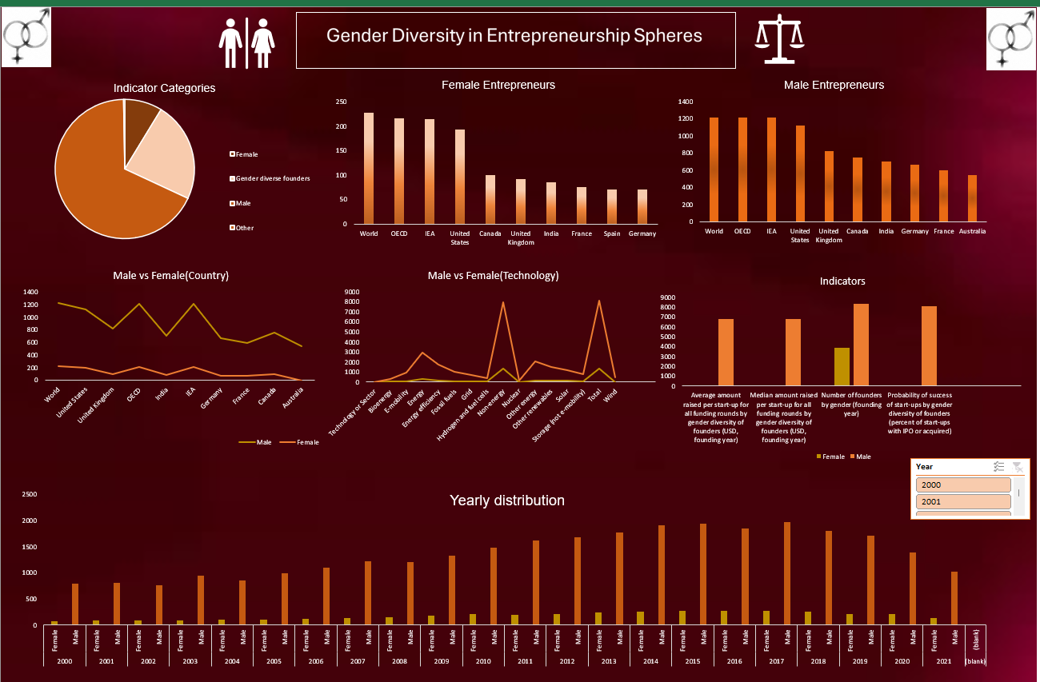

-Analyzing gender diversity trends over different years provides insights into the evolution of women's participation in entrepreneurship.

-Different sectors exhibit varying levels of gender diversity, impacting women's representation in entrepreneurship.

-Explore variations in gender diversity across different countries or regions, shedding light on cultural and socioeconomic influences.

-We can clearly interpret that count of female entrepreneur is very less in different countries

-Certain sectors demonstrate more significant gender diversity challenges than others, highlighting areas for targeted interventions.

**Challenges Faced by Female Entrepreneurs**:

* Women-owned businesses often struggle to secure funding compared to their male.
* Balancing business responsibilities with family and personal life can be particularly challenging for women due to societal expectations and traditional gender roles.
* Women may face discrimination and harassment in the workplace or in business dealings, creating an additional barrier to success.

**Recommendations:**

* Establish and promote gender-neutral funding initiatives to support women-owned businesses.
* Create and support women-focused networking events, conferences, and industry forums.
* Establish mentorship programs connecting experienced female entrepreneurs with aspiring ones.
* Collaborate with educational institutions to develop curricula that address the unique challenges faced by female entrepreneurs.
* Conduct regular reviews of hiring practices to identify and address biases.
* Provide access to mentors, business advisors, and legal support.

**Conclusion**:

In conclusion, the project provides valuable insights into the current state of gender diversity in entrepreneurship, emphasizing the need for concerted efforts to address disparities. The implications and future directions discussed herein pave the way for continued research and action in this critical domain.